**Visual programming Concepts in C# Assignment one**

1. State, explain the .Net framework and give the benefits of each component. **[8]**
2. Differentiate a rectangular array from a ragged array with the aid of examples. **[6]**
3. Discuss the notion that C# is a type-safe, modern and interoperable language. **[6]**
4. Design a windows forms application that performs the following

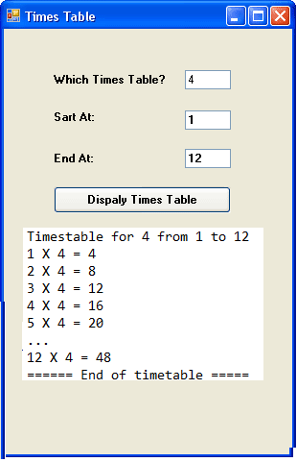

1. Allow the user to input the following variables through text boxes **[3]**
   * any number num
   * starting number start_num
   * end number end_num
2. Use any appropriate loop to multiply num with numbers from start_num to end_num and display the computations in a list box as shown on the fig above. **[6]**
3. The program should display:
   * The opening statement as shown in the fig above **[3]**
   * The closing statement **[3]**

**NOTE**: *Remember plagiarism is a serious academic offence!!!*